COMPUTER NETWORKS

TOPIC:
DEALING WITH SERVERS

NAME:
MUHAMMAD TALHA
SECTION:
4/A
ROLL#:
241890

INSTRUCTOR:
Mr. MUHAMMAD BILAL

LAB TASK#5.1
Implementation of DNS & FTP servers as given below in the picture.
TOPOLOGY:
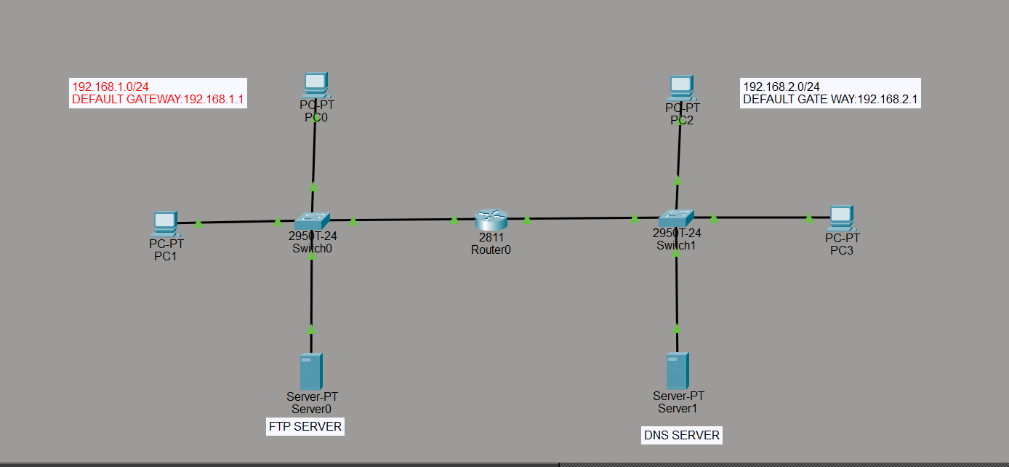
IP FOR PC0(LEFT):
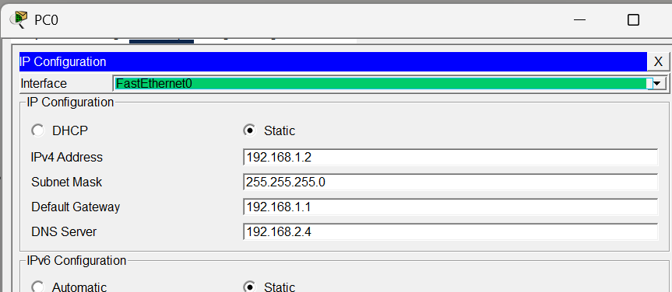

IP FOR PC2(RIGHT):
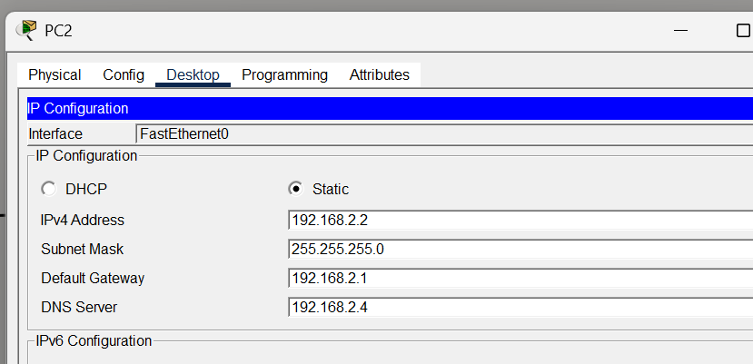
PING FROM PC0(LEFT) TO PC2(RIGHT):
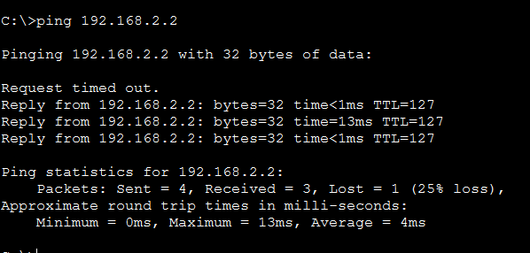
TESTING FTP SERVER FROM PC0(LEFT):
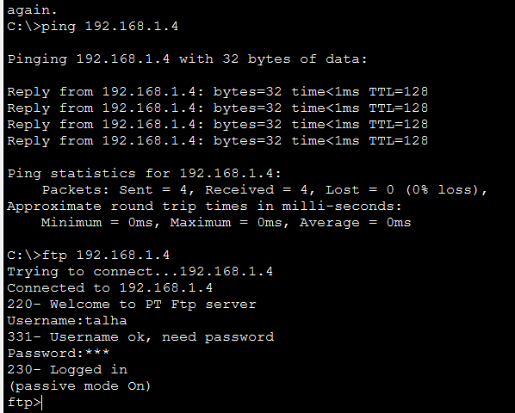
TESTING FTP SERVER FROM PC2(RIGHT):
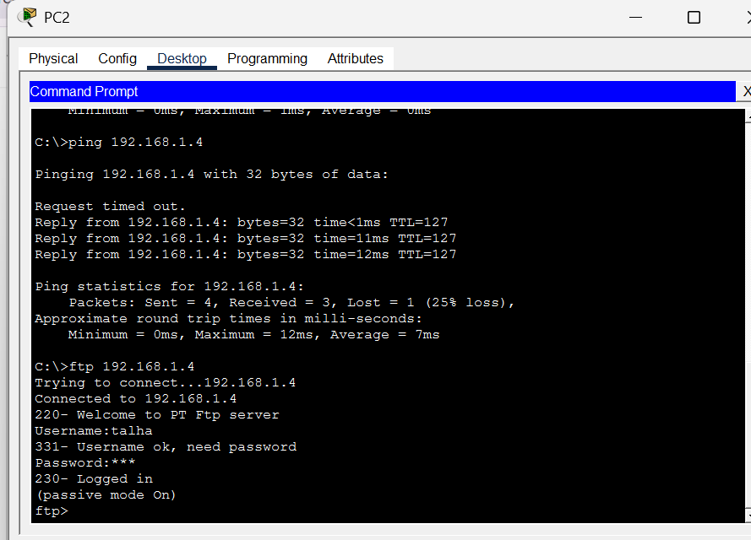

TESTING DNS FROM PC0(LEFT):
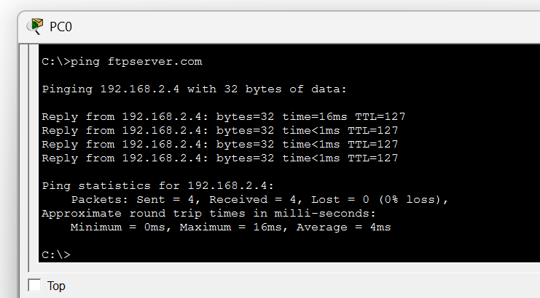
TESTING DNS FROM PC2(RIGHT):
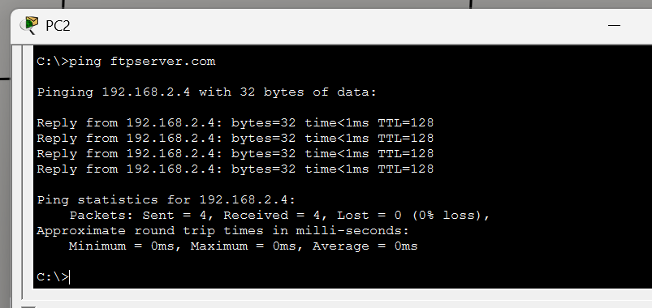

LAB TASK 5.2
Implementation of DNS+HTTP+EMAIL +FTP Servers
4 vLANs with one Switch & one Router
TOPOLOGY:
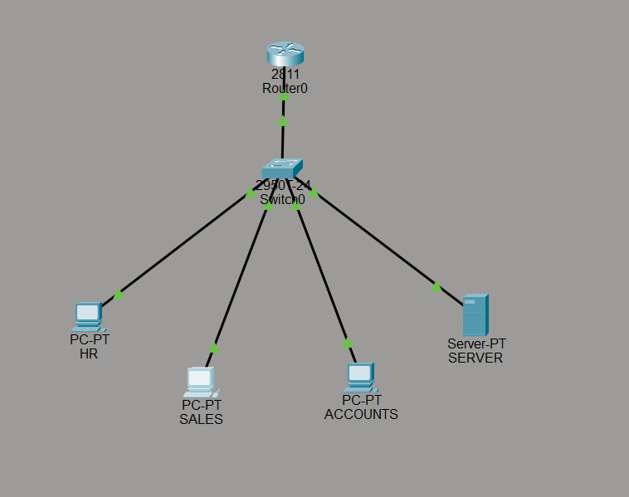
Router config:
enable
config t
interface fa0/0
no shutdown
interface fa0/0.10
encapsulation dot1q 10
ip address 192.168.10.1 255.255.255.0
interface fa0/0.20
encapsulation dot1q 20
ip address 192.168.20.1 255.255.255.0
interface fa0/0.30
encapsulation dot1q 30
ip address 192.168.30.1 255.255.255.0
interface fa0/0.40
encapsulation dot1q 40
ip address 192.168.40.1 255.255.255.0
TESTING FROM HR PC
- PING (DNS TEST)
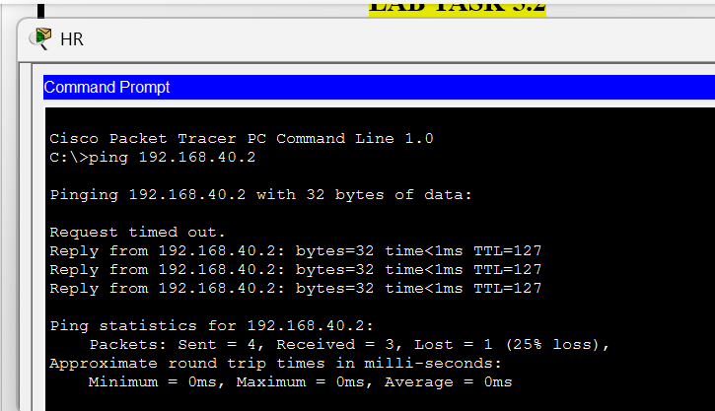
- BROWSER (HTTP TEST):
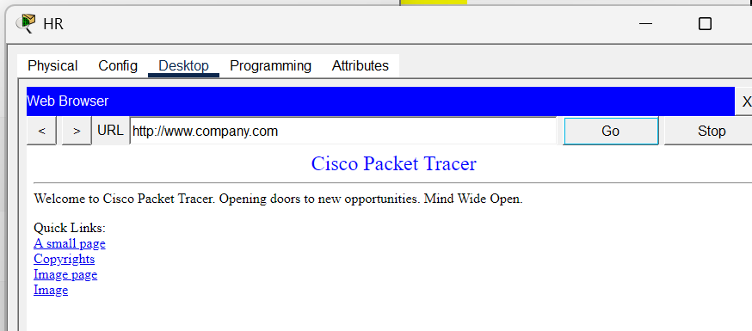
- PING (FTP TEST): 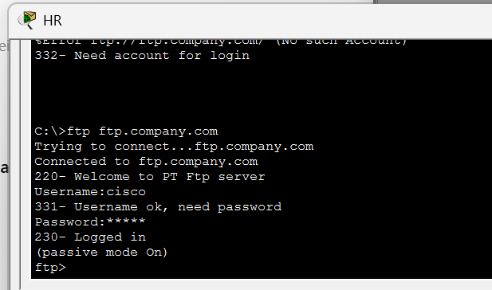
- TEST DNS RESOLUTION:
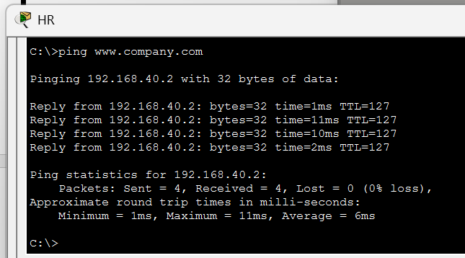
- EMAIL TESTING:
- Set domain name and users:
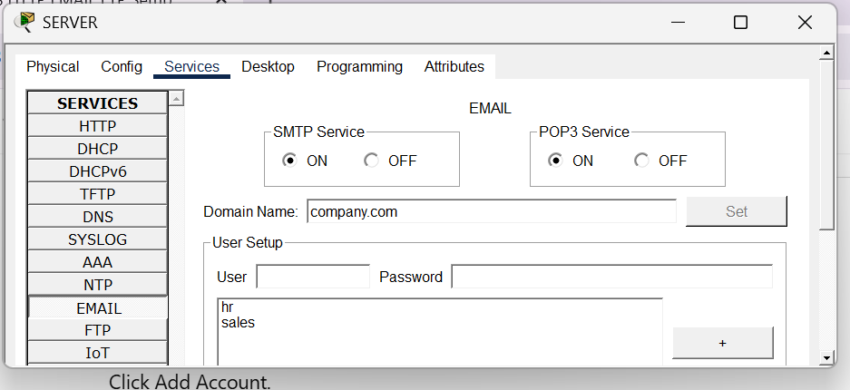
- CONFIGURE THE MAIL
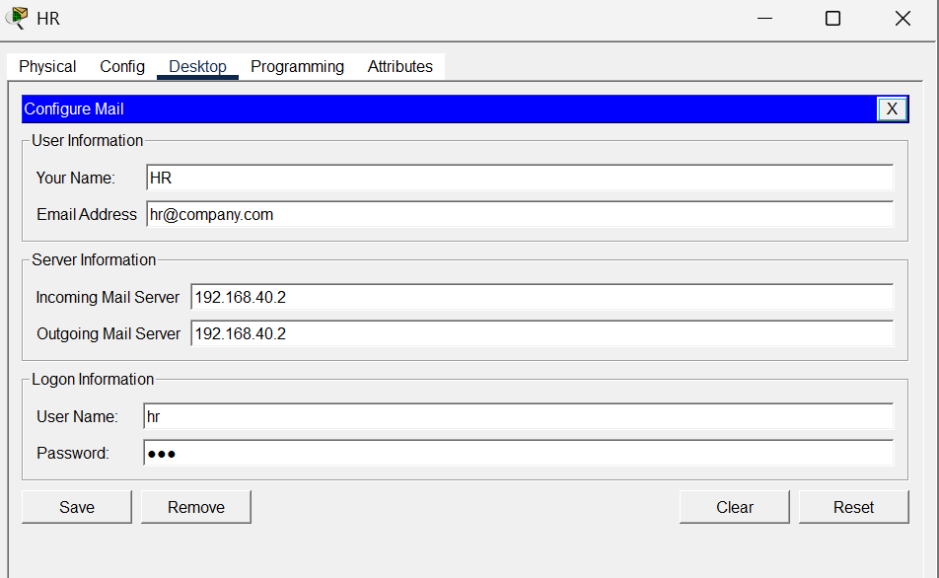
- Compose mail
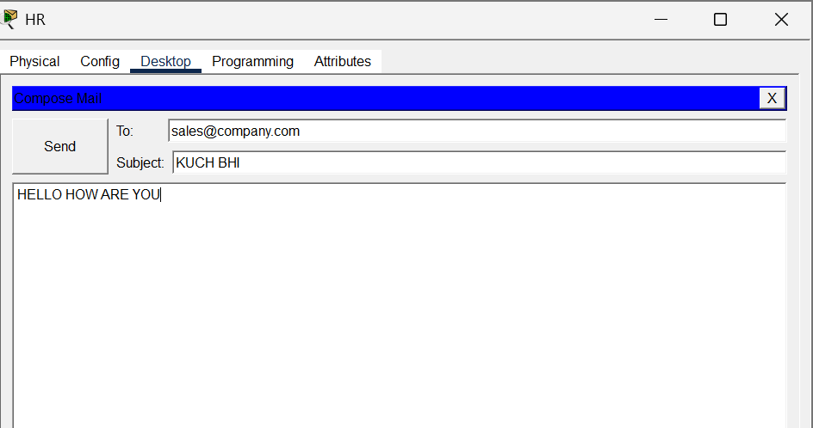
- On other pc check receive status:
